Group Instructions:
- When responding to each question, one group member should be assigned the task of reading the question aloud for the rest of the group.
- Rotate the reading among the group members throughout the assignment so that everyone gets several turns.
- Remember, allow everyone the chance to respond, and respect each other’s ideas, feelings, and answers.
- When your group reaches a STOP sign, stop your work and call Mrs. Cooper over to check your work.

Photosynthesis and Cellular Respiration
What is the relationship between Photosynthesis and Cellular Respiration?

Photosynthesis and cellular respiration are important cell energy processes. They are connected in ways that are vital for the survival of almost all forms of life on earth. In this activity you will look at these two processes at the cellular level and explore their interdependence.

Model 1 – Comparison of Photosynthesis and Respiration

Photosynthesis:
6CO2 + 6H2O + energy → C6H12O6 + 6O2

Sunlight energy
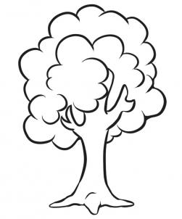

CO2 + H2O

Chloroplast

Mitochondrion

O2

Glucose

energy
(ATP)
O2
Respiration:
C6H12O6 + 6O2 → 6CO2 + 6H2O + energy
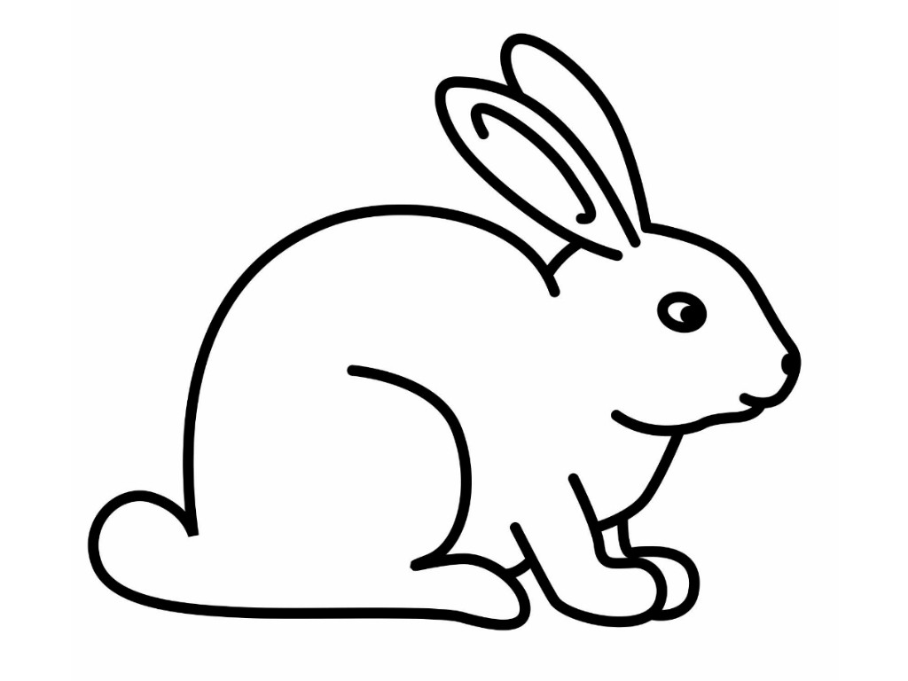

1. Refer to Model 1.
a. In what cell organelle does photosynthesis occur?

b. What are three reactants needed for photosynthesis?

c. What are two products of photosynthesis?

2. Refer to Model 1.
a. In what cell organelle does cellular respiration occur?

b. What are two reactants needed for cellular respiration?

c. What are three products of cellular respiration?

3. What four substances are recycled during photosynthesis and respiration?

4. What is the one component in photosynthesis that is not recycled and must be constantly available?

5. Are chloroplasts found in most plant cells? Explain.

6. Are mitochondria found in most plant cells? Explain.

7. Are chloroplasts found in animal cells? Explain.

8. Are mitochondria found in animal cells? Explain.

9. Write a grammatically correct sentence that compares the reactants and products of photosynthesis with the reactants and products of respiration. Be ready to share your sentence with the class.

10. As a group carefully consider and discuss the following statement: “Plants can survive on their own, because they make their own food. Animals can’t survive on their own but need plants for survival.” Do you agree with this statement? Why or why not? Can you come to a consensus as a group? Be ready to discuss your group’s response to this statement.

11. As a group, make a quick list of the foods that you ate during your last meal. Hypothesize what would happen to the supply of those foods if the sun’s energy was no longer available.

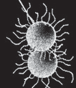
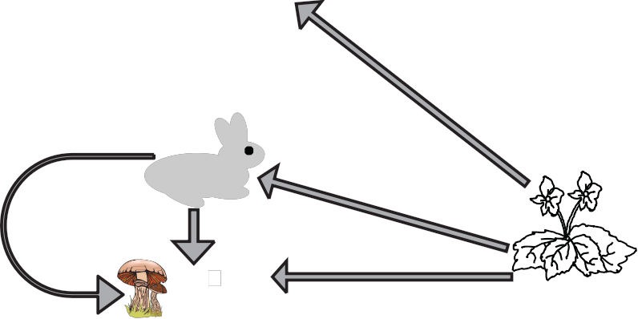
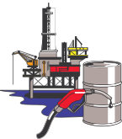
Model 2 – The Carbon Cycle

Atmospheric
CO2 D
C

B

A Wastes

Combustion

Death

Auto and factory emissions

Decay

(by decomposing fungi, bacteria, and worms)

Carbon Stores

12. In the Model 2 diagram, place a green star by each process (A, B, C, or D) that represents photo- synthesis, and a red star by each process (A, B, C, or D) that represents cellular respiration.

13. Write and label equations for cellular respiration and photosynthesis below. Circle the carbon dioxide in each. If you need help, see Model 1.

14. When matter from plants and animals decay (rot), microorganisms responsible for the decomposition process respire. Knowing this information, do you need to add any red stars to Model 2? Explain and add the stars if needed.

15. Ignoring the human actions of auto and factory emissions, what generalization can you make about the balance of carbon dioxide in Model 2 over a long period of time?

16. How would the burning of fossil fuels upset the balance of the carbon dioxide cycle?

