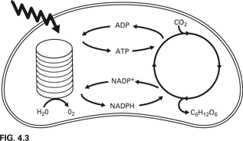**Photosynthesis**

**Putting It All Together!** (**Draw a diagram** showing the pathway and steps involved in photosynthesis from the sequence described below. Label everything!)

1. Photons (light energy) from light hit the surface of leaves or stems that photosynthesize and penetrate through to middle layer of leaf called **mesophyll layer**.
2. Mesophyll cells that contain chloroplasts absorb photons and capture energy by using pigment **chlorophyll.**
3. Chlorophyll gets “excited” and passes the energy along to the **Light Reaction** portion of photosynthesis. The light reactions occur on the inside of chloroplasts on the surface of their stacks called **grana.**
4. The job of the Light Reaction is to produce **ATP** and **NADPH**. Think of these two molecules as packets of energy that power further reactions. **Water** is split in the process and **O2** is produced as a waste product.
5. ATP and NADPH from Light Reaction power the **Calvin Cycle** to take **CO2** from the air and connect them to make **glucose**. All gases enter and exit the leaf through tiny holes on their undersides called **stomata.**
6. Glucose is hooked up to create **starch**, which is then stored in the plant’s roots and used for food.
7. ATP and NADPH are “used up” during Calvin Cycle. They lose molecules and become ADP and NADP, respectively. They need to be re-created so are returned to Light Reaction to get “re-energized”.
8. Continued exposure to light energy causes whole thing to start over!

