Mitosis Web Quest
http://www.cellsalive.com/
On the left side of the screen is a navigation bar, click on the link to “mitosis” Read the text on this page and the view the animation, you can slow down the video by clicking step by step through the phases.
- Which stage does the following occur:
  - Chromatin condenses into chromosomes ____________________
  - Chromosomes align in the center of the cell ____________________
  - Longest part of the cell cycle ____________________
  - Nuclear envelope breaks down ____________________
  - Cell is cleaved into two new daughter cells ____________________
  - Daughter chromosomes arrive at the poles ____________________
  - Chromatids are pulled apart ____________________
- The colored chromosome represents chromatids. There are two of each color because one is an exact duplicate of the other. How many chromosomes are visible at the beginning of mitosis?
  - How many are in each daughter cell at the end of mitosis? _____________________
  - The little green T shaped things on the cell are: _____________________
  - What happens to the centrioles during mitosis? _____________________
- Identify the stages of these cells:
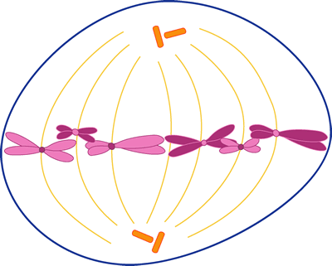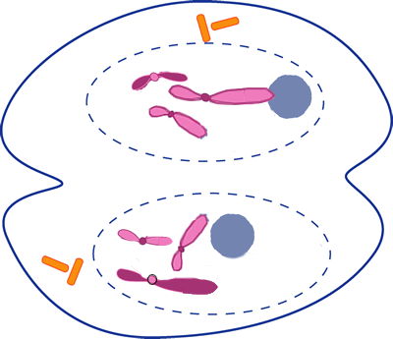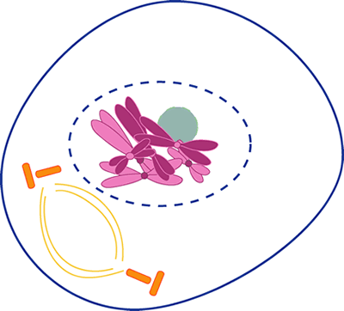
______________________ ________________________ _________________________

Another Mitosis Animation
http://www.johnkyrk.com/mitosis.html Draw a cell in each of the following phases.
Prophase | Metaphase | Telophase

Onion Root Tip
http://www.biology.arizona.edu/cell_bio/activities/cell_cycle/cell_cycle.html
Read the introduction, and then click the “next “button.
You will have 36 cells to classify. When you’re finished, record your data in the chart below. Round to whole numbers.
 | Interphase | Prophase | Metaphase | Anaphase | Telophase | Total
Number of cells

Percent of Cells(calculate: number of cells divided by total cells X 100)

Mitosis in Whitefish & Onion Roots
http://www.biologycorner.com/projects/mitosis.html Click on the whitefish embryo and the onion root tip. For each organism, identify the stage of mitosis.
 | View 1 | View 2 | View 3 | View 4 | View 5
Whitefish

Onion

You Draw it!
Use the space below to draw the four stages of mitosis your own way, be sure to represent the major events of each phase and label the structures.

