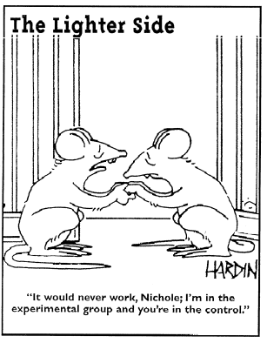
Antibacterial Stuff Lab Planning Sheet

1. What bacteria are you going to use? What are you going to test – be specific?

- Research Question: “What is the effect of ________________________ on bacterial growth, as measured by a zone of inhibition”?

- Hypothesis & Data-Based Explanation: “If there is a relationship between _____________________ and the size of the zone of inhibition, then…

- Variables Table: So every good experiment needs an EXPERIMENTAL GROUP, CONTROL GROUP, and a whole lot of things you need to keep constant.
My Experimental Group is: Paper disks soaked with ( )
My Control Group is: Paper disks soaked with ( )

Variable to Control | How Could it Alter Results? | How Will YOU Keep it Constant?

How many times I will repeat the experiment (“Multiple Trials”) _________________ times

- Materials List: (Add any materials that you used but are not listed below)
1- Petri dish with agar
1-beaker of ethanol
1-beaker distilled water
1-tweezer
4 - Sterilized paper disks

- Procedures: Now in a step-by-step way, write down from the very start the procedures you used for your experiment. REMEMBER TO BE AS SPECIFIC AS POSSIBLE!

- Clean the lab table.

- Write initials in the bottom edge of your petri dish. Label one quadrant with control and the other 3 experimental.

3. using a sterile pipette, add 5 drops of ___________________ bacteria to the petri dish.

4. Remove the spreader from the beaker of alcohol. After the spreader is dry, open the petri dish and spread the bacteria over the entire surface of the agar. (Put the spreader back in the alcohol.)

5. Remove the tweezers from the alcohol. After the tweezers are dry, pick up a sterile paper disk and dip it into the distilled water.

6. Remove the lid of the petri dish and place the disk on the agar in the CONTROL quadrant. GENTLY press the disk onto the agar.
Paper Disk

7. Place the tweezers back into the alcohol.

8. Remove the tweezers from the alcohol. After the tweezers are dry,
Pick up a sterile paper disk and dip it into ______________ / and ________________
pick up a ________________________ antibiotic disk.
Petri Dish

9. Remove the lid of the petri dish and place the disk on the agar in one of the Experimental quadrants. GENTLY press the disk onto the agar. Repeat with your two other antibacterial agents. Make sure your dish is labeled with what is in each quadrant.

10. Return lid to the petri dish. Flip the petri dish upside down. Make sure that the paper disks stay on the agar.

11. Place the petri dish the incubator.

- Data Collection: Don’t forget UNITS and a nice TITLE! You won’t necessarily have any data to put in today but don’t forget to leave spaces for Multiple Trials!
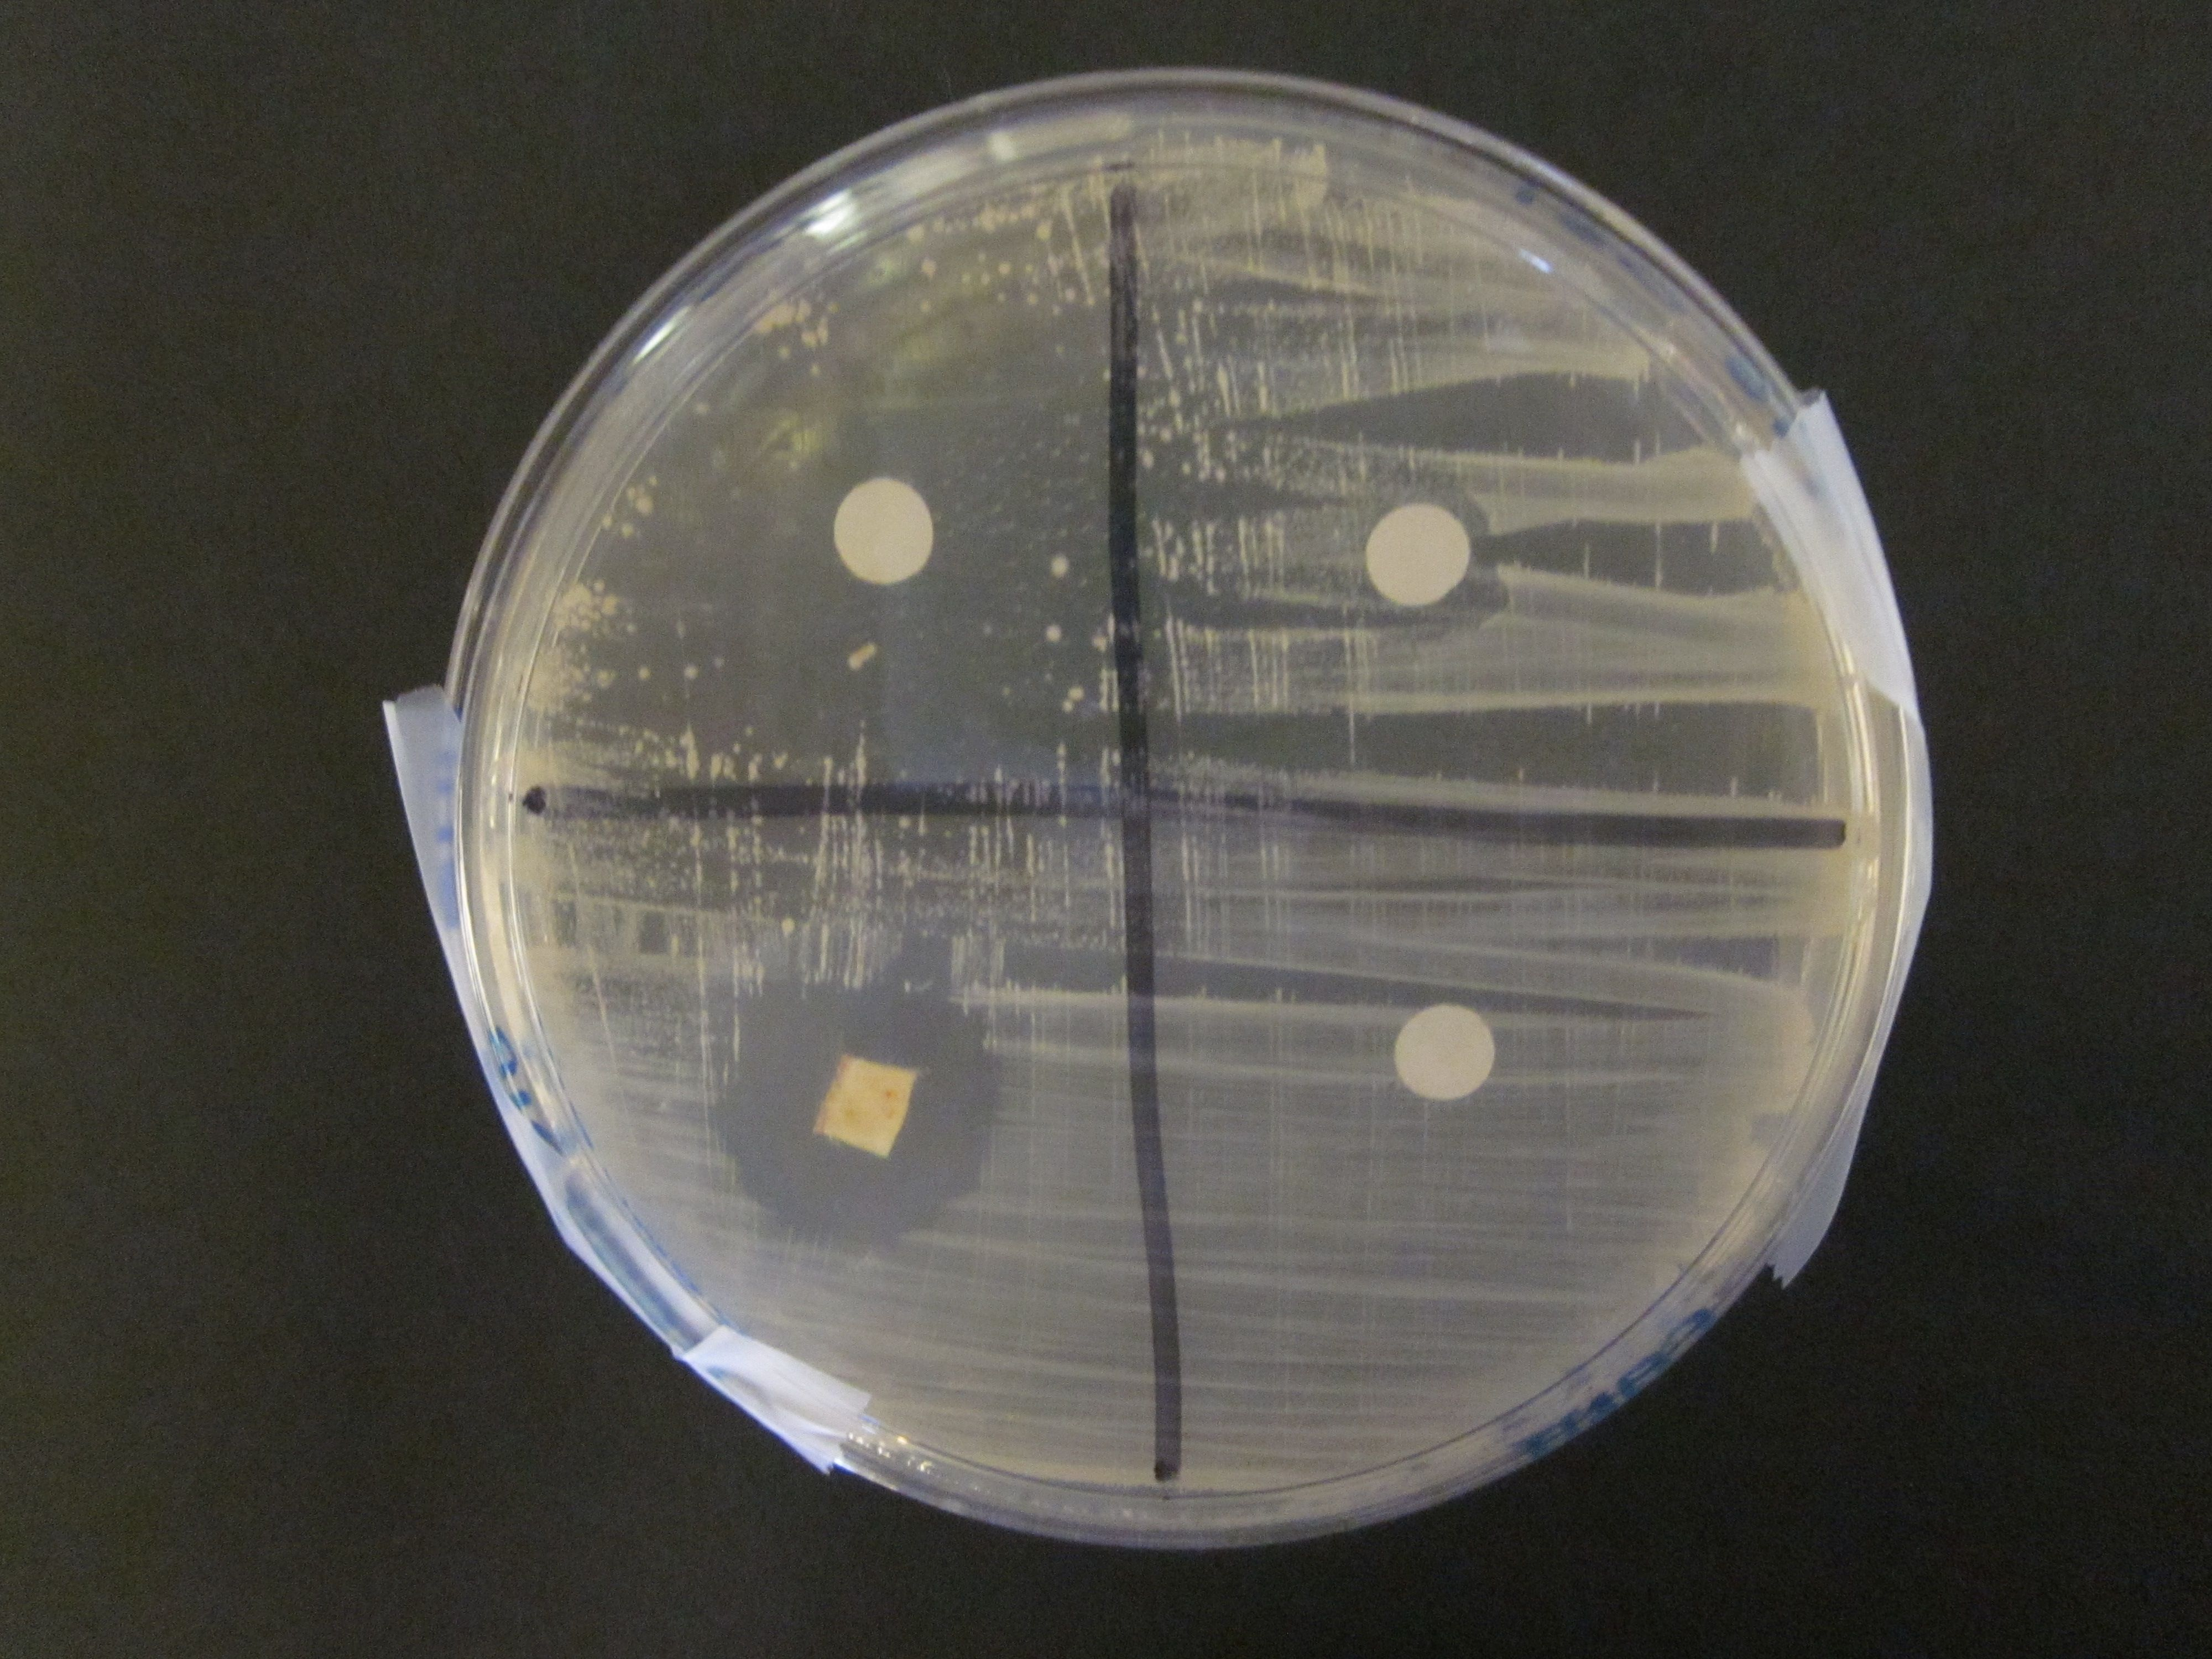
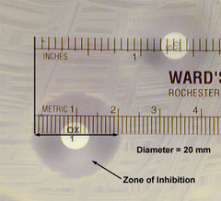
Data Table 1: The Effect of ________ on Zone of Inhibition (mm)

